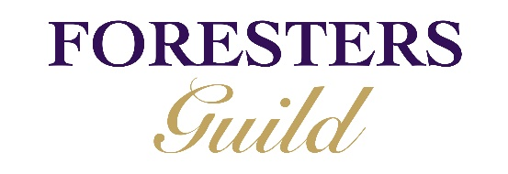

Starters

Breadwinner Bread Salted Butter £ 3.95
Gordal Olives Sweet Paprika Marinade £3.5
Halloumi Fries Sriracha Mayo £6.50
Beetroot Hummus Grilled Arabic Flat Breads £5.95

Soup of the Day Breadwinner Bread, Salted Butter £4.95

Mac & Cheese Bon Bon’s Sweet Chilli Dipping Sauce £6.50
Findlays of Portobello Haggis Pickled Neeps, Potato Crisps, Red Wine Sauce £7.50
Campbells & Co Smoked Salmon Sesame Seaweed Salad, Wasabi Emulsion, Bread £7.50

Steak

John Gilmour’s 8oz Flat Iron Steak served with your choice of triple cooked chips or skinny fries £14.95

Add sauce: Garlic & Parsley Butter £1.95
Peppercorn and Haggis Sauce £1.95

Buns

All served with skinny fries
Moving Mountain Burger Vegan Mushroom & Beetroot Burger, Lettuce, Tomato Chutney, Veganaise, Red Onion & Gherkin £10.95
10oz Foresters Beef Burger Breadwinner Bun, Burger Sauce, Lettuce, Tomato, Red Onion, Gherkin £11.95
Cajun Spiced Chicken Burger Breadwinner Bun, Lettuce, Mango Yoghurt, Asian slaw £11.95
Porty Cheesesteak Braised Beef Brisket, Red Peppers, Onions, Cream Cheese & Monterey Jack £11.95

Add Back Bacon £1
Add Monterey Jack Cheese £1
Add Blue Murder Cheese £2

Mains
Braised Border’s Featherblade of Beef Mushroom Ketchup, Truffle & Parmesan Chips & Crispy Kale £12.95
Smoked Haddock, Parsley & Spring Onion Fishcake Tartar Sauce & Triple Cooked Chips £11.95
Deep fried Peter Ranaldi Haddock Triple Cooked Chips, Tartar Sauce & Lemon Half £9.95 / Full £12.50
Vegan Sweet Potato, Aubergine & Red Pepper Tagine Pomegranate & Coconut Yoghurt, Chargrilled Flatbread £10.95

Turn over for some extras….

Foresters Fries

Skinny Fries or Chunky Chips

Naked Fries £2.95
Truffle Fries, Truffle Oil & Parmesan £4.50
Salt & Chilli Fries, Sriracha, Spring Onion, Blue Murder £4.50
Haggis & Peppercorn Fries, Findlays Haggis, Peppercorn Sauce £4.50

Desserts
Very Sticky Toffee Pudding Toffee Sauce, Overlangshaw’s Vanilla Ice Cream £5.95
Lemon Posset Chefs Honeycomb & Raspberries
£5.95
Chefs Selection of Scottish Cheeses Chef’s Chutney, Arran Oaties, Pickled apples £7.95
Overlangshaw Farmhouse Ice Cream & Sorbets £1.50 per scoop

Due to the nature of business post Cov-19 lockdown we have decided to start with a reduced menu in order to focus on keeping both our staff and customers safe as well as ensuring we can continue our usual level of homemade food & friendly service. We thank you for your patience and your support during this time.

